Hardware Lab Kit (HLK) for Near Field Communication (NFC)
The HLK for NFC validates that the NFC driver implementation meets Microsoft specifications. Although we have added the ability to run tests manually, for automated, faster and more reliable testing for the HLK NFC test suite, we recommend that partners acquire the NFC Interoperability Test Tool (NITT).
The NITT simulates T1T, T2T, T3T, and T4T NFC forum tag. In another to tag simulation, the NITT has a robot arm that moves an RF shield, simulating tapping/un-tapping operations for Peer-to-Peer operations. The following image illustrates the NITT setup.
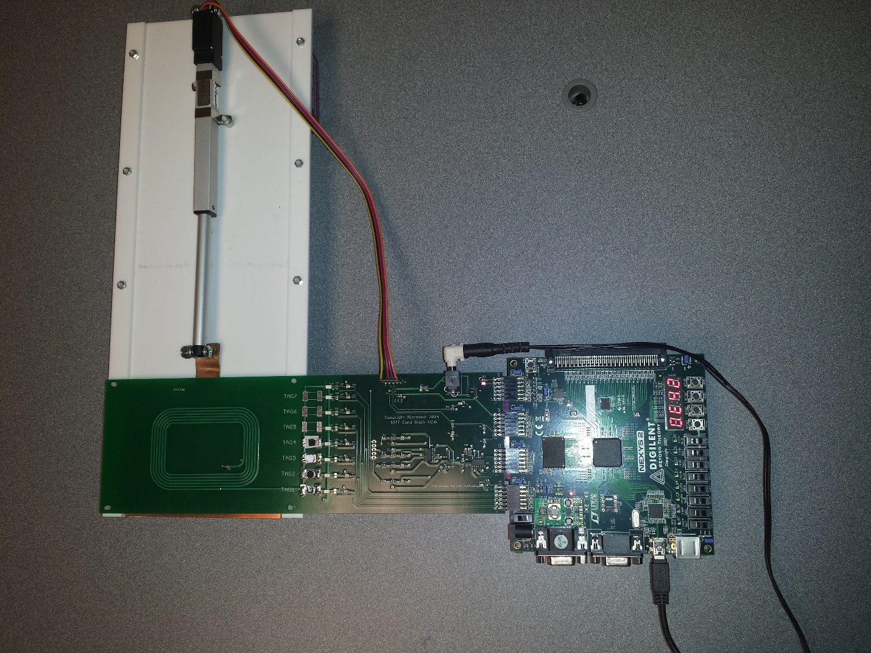
The NITT is powered with an external power supply of 7.5v and is connected to the client PC.
To acquire the NITT, please contact:
JJG Technologies LLC
1034 231st Pl NE
Sammamish, WA 98074
Phone: (206) 304-1921 Fax: (208) 298-0623
inquiry@jjgtechnologies.com

After setting up the HLK test framework:

Hardware Requirements:
- Device with NFC chip that implements the NFC driver DDIs and is subject to compliance tests (referred to as Device Under Test (DUT))
- Desktop PC with USB port (PC client.)
- NITT board connected to the PC client.
- Device with NFC chip that implements NFP and smart cards (NFC client.)
Please note that desktop DUT, PC client and PC NFC client require the installation of Visual C++ Redistributable Packages for Visual Studio 2013. These packages are available directly from the Microsoft Download Center.

Test Execution

Before you run the test
- Make sure HLK client is deployed to DUT.
- Place the DUT on top of the NITT board NFC antenna.
- Place NFC client below the NFC antenna and the RF shield of the NITT.
- Make sure DUT, NFC client, and PC client have Visual C++ Redistributable Packages for Visual Studio 2013 installed.
- Make sure DUT, NFC client and PC client have network connections.
Currently, full automation of test execution is not supported. HLK studio/controller would deploy and run the test case on DUT. Those test case would require helper binaries to be launched manually. In order to do so, the following clients need to have the following setup:

The HLK studio/controller deploys and runs test cases on the DUT but some intervention on the tester’s part is required. For test cases where manual intervention is required, the helper binaries need to be launched manually. In order to do so, the NFC and PC clients need to have the following setup:

NFC client
- Create a working folder and Copy TAEF binaries corresponding to the client arch from HLK controller. For a typical HLK studio setup, the TAEF binaries will be located in:
“C:\Program Files (x86)\Windows Kits\10\Testing\Runtimes\TAEF\<arch>\*”
to the working directory.
Where <arch> is either x86, x64, arm, arm64.
- Copy NfcRemotePeerService.dll from the HLK studio location
“C:\Program Files (x86)\Windows Kits\10\Hardware Lab Kit\Tests\<arch>\NFC\NfcRemotePeerService.dll”
to the working directory created above.
Where <arch> is either x86, amd64, arm, arm64.

PC client (*setup if using NITT)
- Create a working folder and Copy TAEF binaries corresponding to the client arch from HLK controller. For a typical HLK studio setup, the TAEF binaries will be located in:
“C:\Program Files (x86)\Windows Kits\10\Testing\Runtimes\TAEF\<arch>\*”
to the working directory.
Where <arch> is either x86, x64, arm, arm64.
- Copy NfcNittController.exe from the HLK studio location
“C:\Program Files (x86)\Windows Kits\10\Hardware Lab Kit\Tests\<arch>\NFC\ NfcNittController.exe”
to the working directory created above.
Where <arch> is either x86, amd64, arm, arm64.
- Copy MuttUtil.dll from the HLK studio location
“C:\Program Files (x86)\Windows Kits\10\Hardware Lab Kit\Tests\<arch>\usb\MuttTools\MuttUtil.dll”
to the working directory created above.
Where <arch> is either x86, amd64, arm, arm64.

Running the test using HLK

HLK Studio
- In HLK studio, select the test from the “Tests” tab as per following image:
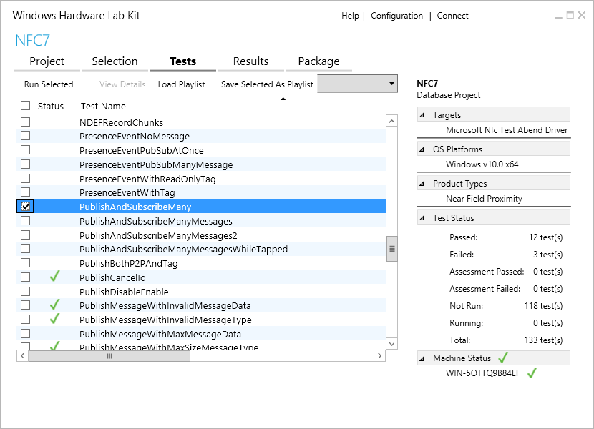
- Click “Run Selected:
- If you are running the tests manually (without the NITT) then change the Parameters value from nitt to manual as following:
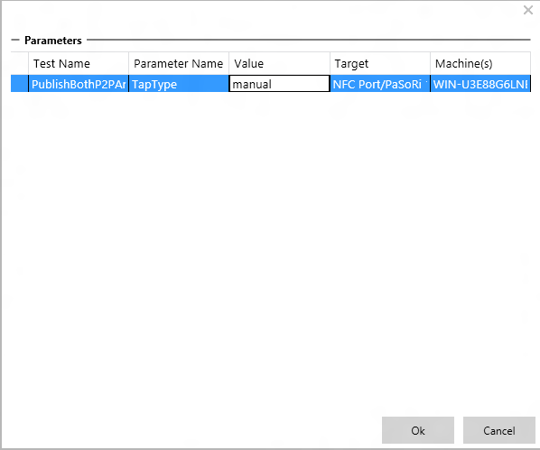

NFC client
- Change to the working folder created above.
- Run the following command:
TE.exe NfcRemotePeerService.dll /p:server=<ip_of_dut>
Where <ip_of_dut> is the IP address of the DUT

PC client (*setup if using NITT)
- Change to the working folder created above.
- Run the following command:
nfcnittcontroller.exe -server <ip_of_dut> -tagIndex <tag_index>
Where <ip_of_dut> is the IP address of the DUT,
<tag_index> is the NITT board tag index. Possible values are 1, 2, 3, and 4 corresponding to NFC Forum compliant T1T, T2T, T3T, and T4T, respectively.

